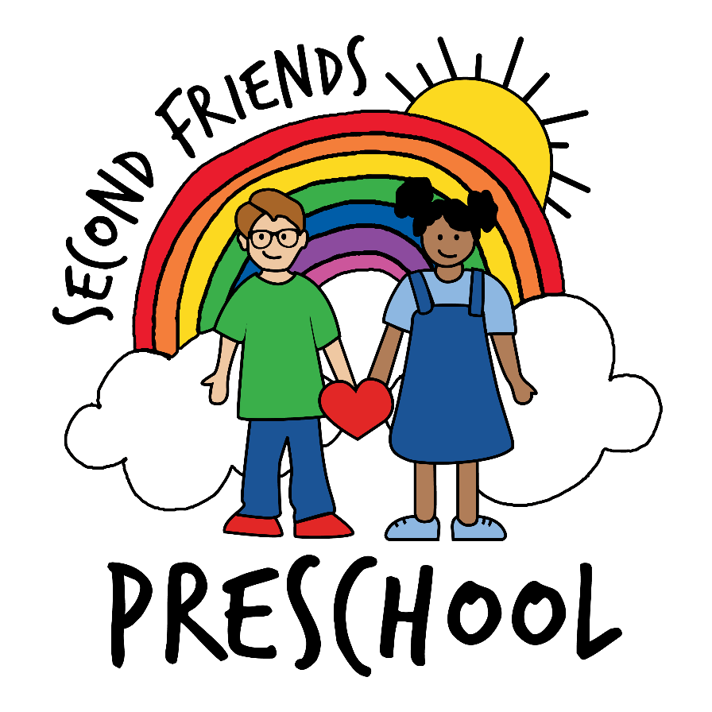

Parent Handbook
2026-2027



Second Friends Preschool

Contact Information

Address Second Friends Preschool
Second Baptist Church
300 E. Kansas Street
Liberty, MO 64068

Phone 816-781-3882 (Preschool)
816-781-2824 (Church)

Director Kate Tysdahl

Email sfpdirector@2bcliberty.org

Second Friends Advisory Board Chair
Chelsea Hilton
clwininger@gmail.com

Facebook: Second Friends Preschool (Public business page)
Please connect with us on Facebook. Facebook is used to remind you of special events, preschool closings, and to give you an occasional peek into the happenings at preschool.

Website
www.2bcliberty.org/second-friends-preschool

Brightwheel
The Brightwheel app is our main tool for communication with parents. Please watch the app for reminders of special events, preschool closings, and peeks into the happenings at preschool.

WELCOME!

Second Friends Preschool is a ministry of Second Baptist Church, Liberty MO.
Parents, we welcome you to our program, and we look forward to working with you and your child.

Mission
We provide a happy and secure learning environment for each child. We communicate our Christian faith through the way we speak, act, listen, react, and care. We provide many opportunities for children to discover, explore, question, wonder, and discuss experiences.
We believe that each child is a unique individual created by God with specific abilities and differences. We help each child grow socially, physically, cognitively, and spiritually at his or her own pace. We build a foundation for children who may always love to learn and create, who are not afraid to make mistakes, who embrace Jesus and His love, and who enjoy being part of a community of friends.
We believe the best assurance for the success of children is the close cooperation between parents and preschool staff.
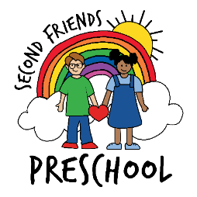

Admission Policy and Enrollment

Second Friends admits students of any race, color, nationality, and ethnic origin and does not discriminate on the basis of race, color, nationality and ethnic origin in administration of its educational policies, admission procedures and other school administered programs.

Enrollment is for either the entire school year or the balance of the school year. When the enrollment forms are completed and enrollment fee (see “Tuition and Fees”) is paid, a spot is reserved for the student in one of the class sessions. A returning student must also be in "good standing" financially at the end of the school year or their spot will be released.

Overview of Curriculum

Second Friends Preschool has offered a preschool built on the Christian values of love, grace, and acceptance for children ages 3-5 since 1995. Our preschool program promotes a positive and nurturing environment for each child to learn and grow academically, emotionally, physically and spiritually.

We use Missouri Early Learning Standards to plan our curriculum. Additionally, we offer Bible Time, Music, Spanish, and classroom activities at developmentally appropriate levels. Children have daily outdoor playtime as weather permits. At Second Friends, we believe free play is invaluable for children to learn both academically and socially. Children are curious by nature, so they acquire, practice, and master skills best through play. Children discover more about themselves through trial and error. We see mistakes as learning opportunities. If young children discover that learning can be exciting, there is a strong possibility they will continue to enjoy the adventure of education in the future.
Our preschool emphasizes the following:
- Socialization and group interaction
- Development of a positive self-image in a loving, caring environment
- Emotional self-regulation
- Opportunities to work in large groups, small groups and independently
- Fine motor and gross motor development
- Pre-Kindergarten skills in the areas of language/literacy, math, and science
- Music, art, and foreign language appreciation
- The Christian values of love, grace, and acceptance

Enrollment

The State of Missouri requires all students to have the following forms on file by the first day of attendance.

1. Enrollment Form with current emergency contact information
- Note: If there are changes to the information provided on the enrollment forms, parents are responsible for providing updated details. It is essential that we maintain current contact information for all families, including parent phone numbers and email addresses, emergency contacts, and the names and details of individuals authorized to pick up children.
2. Medical Authorization Form

3. Notice of Parent Responsibility Form

4. Signed permission forms are also required for the following:
- Photographs for press releases, our website, or social media
- Field trip attendance

5. Health Records
- Health and up-to-date immunization records are due prior to the first day of preschool.
- All children must be fully immunized according to the American Academy of Pediatrics Recommended Child and Adolescent Immunization Schedule.
- Requests for medical exemptions will be considered.
- We do not accept religious immunization exemption forms for children.

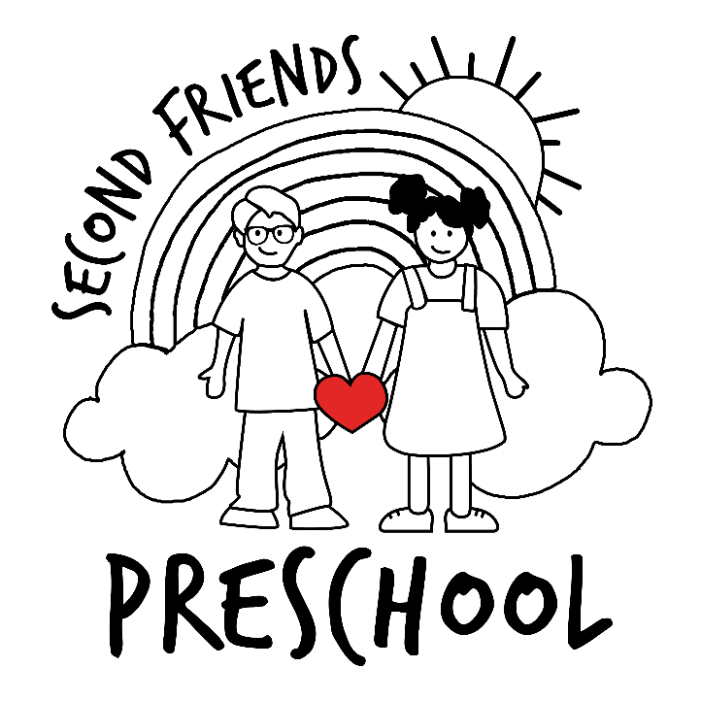
Preschool Policies and Procedures

Program Options
For those who have turned 3 years old prior to Aug 1:
- 3s/4s class: Tuesday/Thursday (9am-1pm OR 9am-3pm)
- 3s/4s class: Tuesday/Wednesday/Thursday (9am-1pm OR 9am-3pm)
For those who have turned 4 years old prior to Aug 1:
- Pre-K 3 Day class: Tuesday/Wednesday/Thursday (9am-3pm)

Tuition & Fees
- $110 non-refundable registration fee is due with enrollment form.
- 2 Day Tuition: $270 per month (9am-3pm)
- 2 Day Tuition: $181 per month (9am-1pm)
- 3 Day Tuition: $400 per month (9am-3pm)
- 3 Day Tuition: $272 per month (9am-1pm)
- Tuition is due on the 5th of each month, beginning Aug. 5 and ending April 5. If specific situations prohibit families from participating in payments through Brightwheel, they can speak with the Director. Arrangements can be made to pay at the beginning of each semester.
- No credit is given for absences, i.e., illnesses, vacations, or canceled preschool days.
- There is a $10 late charge per child beginning 10 minutes past the dismissal time, and an additional $1 for each minute beyond the initial 10 minutes.

Attendance and Health Policies
All children must be fever-free, vomit-free and diarrhea-free for 24 hours before returning to preschool from an illness.
For the health of your child and others, please keep your child home for the following reasons:
  - Fever of 100.4 or higher in the past 24 hours
  - Vomiting or diarrhea within the past 24 hours
  - Feeling unwell and not able to participate in routine school activities
  - Draining sores/lesions that cannot be adequately covered
  - Other contagious illnesses at the discretion of the preschool director and teachers.
- If a child becomes ill during the school day, a parent or person listed as an emergency contact must be available to pick up the child.
- Any child with specific health concerns that might impact them during the preschool day (i.e., asthma, food allergies, or a seizure disorder) must have an action plan from the health care professional and appropriate emergency medications that can be left at school. Please contact the Director for more information.

Fundraisers
- Fundraisers help support field trips, special events, classroom supplies, equipment, and our Spanish and Music programs. Parent participation is optional but greatly appreciated.
- Fundraising information will be shared through weekly newsletters. Be on the lookout for opportunities to get involved!

Communication
- Please notify your child’s teacher or the director if your child will be absent. Brightwheel is our preferred method of communication, though you may also call or email.
- If you have concerns and would like to schedule a conference, please contact the director or your child’s teacher. Teachers are unable to give full attention to concerns during drop-off and pick-up times.
- Parents will receive weekly newsletters along with important upcoming dates and reminders.

Termination
A child may be dismissed from Second Friends by the director for the following reasons:
- Failure to comply with school policies as outlined in the Parent Handbook.
- Ongoing behavior that endangers the well-being of other students or significantly disrupts the learning environment. Prior to dismissal, every effort will be made to help the child develop pro-social behaviors. Incident reports will be sent home, and a conference will be held with the child’s parent, teacher, and director.
- Non-payment of tuition or fees.

Safety and Security
- All teachers and assistant teachers are registered with the Family Safety Care Registry and have completed required background checks.
- Select staff are trained in CPR and First Aid.
- The building remains locked during preschool hours. Entry may be requested by pressing the buzzer.
- An emergency plan includes regular fire and tornado drills. Every effort is made to keep children calm and reassured during drills.
- Staff are trained on procedures in the event of a dangerous intruder.
- Staff are aware of and monitor the Missouri Sex Offender Registry for individuals residing within 1,000 feet of the preschool.

The Preschool Day

Arrival at Preschool
Arrival times will be staggered by class to help keep hallways free from congestion. Each class will be assigned a 10-minute arrival window at the curb.
Staff members will greet parents and children at the entrance and escort students into the building, where a teacher will be waiting.
Dismissal Procedures at the End of the Preschool Day
Dismissal is also staggered, with each class assigned a 10-minute pick-up window. Staff will remain with children until parents/caregivers arrive at the sidewalk.
Once children are safely secured in vehicles, parents are asked to promptly leave the curb so that the next class may begin dismissal.
During the Day
Preschoolers are assigned to classrooms led by a teacher and assistant teacher. Each class participates in a daily “special,” including Music, Spanish, or Bible Time.
The day is filled with developmentally appropriate learning activities planned by the teachers. Instruction is guided by the Missouri Early Learning Standards (MELS).
School Closure
- If the Liberty Public School District closes or moves to online learning, Second Friends Preschool will also be closed.
- The director may cancel preschool when Liberty schools are in session if weather conditions are unsafe for young children. Parents will be notified as early as possible.
- No tuition refunds or make-up days will be provided for school closures.

Early Release Days
- Early release (noon) days are scheduled in conjunction with certain programs and are noted on the school calendar.
- Children do not need to bring lunch early release days.
- Extended care is not available on early release days.

Extended Care
- Extended care is offered on Tuesdays and Thursdays from 3:00–4:00 p.m.
- The monthly fee is $55.
Additional Information

Bathroom Expectations
To ensure the health, safety, and developmental readiness of all children enrolled, our preschool requires that all students be fully potty trained upon enrollment.

In accordance with Missouri Code of State Regulations, and due to the design of our facility, we do not have diapering or changing stations and are unable to provide diapering services. Of course, staff will assist with verbal reminders and clothing fasteners.
For the purposes of this policy, “potty trained” means that a child can:
- Independently use the toilet
- Clearly communicate toileting needs to a teacher
- Manage clothing before and after toileting (including pulling pants up and down)

Children should be able to complete the toileting process with minimal assistance and remain in underwear during the school day. We recognize that toilet-training is a new skill for more students, and accidents are understandable.

We also understand that accidents may occur more frequently in a new environment. For this reason, a grace period of 2–4 weeks may be provided at the beginning of enrollment or the start of the school year to support each child’s adjustment.

If, after the initial adjustment period, a child is experiencing frequent toileting accidents that significantly interfere with participation in the program, the school may request a temporary break from attendance of up to two (2) weeks to allow families time to focus on toilet learning at home. The child’s enrollment placement will be reserved during this break.

We appreciate families’ cooperation and partnership in helping ensure a safe, sanitary, and developmentally appropriate learning environment for all students.

Clothing and Supplies
- Send a labeled extra change of clothing to remain at school.
- Label all clothing, jackets, and backpacks.
- Dress children in comfortable clothing suitable for painting, outdoor play, and independent bathroom use.
- Choose sturdy, closed-toe shoes appropriate for playground use. Crocs, flip-flops, sandals, and dress shoes are not recommended.
- Children should bring a backpack daily for projects and communication.

Discipline
Second Friends Preschool uses positive guidance and redirection to address inappropriate or disruptive behaviors. Our goal is to teach self-control in an environment that fosters responsibility, kindness, and respect.
Throughout the year, children are taught to (1) Respect the rights and feelings of others, (2) Make thoughtful choices, (3) Use words to express feelings, (4) Share materials, (5) Follow routines, and (6) Learn from mistakes. Second Friends does not employ corporal punishment.

Second Friends Preschool does not use corporal punishment.
Discipline strategies may include:
- Modeling appropriate behavior (“Blocks are for building, not throwing.”)
- Helping children understand how their actions affect others
- Assisting children in resolving conflicts
- Brief separation from the group when necessary, followed by discussion once calm
Parents will be informed of inappropriate behavior verbally or through incident reports. Written reports of serious behavior will be kept in the student’s file.
If there are significant changes at home that may impact behavior, please inform your child’s teacher. This information will remain confidential and help us support your child.
Field Trips
- Walking field trips within downtown Liberty may occur. Parents will be notified in advance.
- Additional field trips may be scheduled with prior parent notification and consent.
- Permission is granted through enrollment forms kept on file.

Medication
If medication must be administered during preschool hours:
- It must be provided in the original container.
- Written, dated parental permission is required. Prescription medications must have the pharmacy label attached.
- The container must be labeled with the child’s name.
- Clear dosage instructions (time and amount) must be included.
- Medication will be stored securely out of children’s reach.
- EpiPens, inhalers, and ongoing medications may be stored in the office for accessibility.

Parent Participation
- We have special days throughout the year when we encourage parent participation. Parents will be invited to join us for several activities, including the Christmas Program and Last Day Celebration. We also love to have parent volunteers. We welcome help at preschool events.

Quiet Time
- Full-day students participate in quiet time for approximately 45 minutes to 1 hour.
- The preschool provides individually assigned nap mats.
- Students may bring a small blanket or comfort item.

Snacks/Lunches
- Parents will be notified of any classroom food allergies.
- Families take turns providing a nutritious class snack (fruit, crackers, cheese, cereal, etc.).
- Individually wrapped items are preferred. If not individually wrapped, staff will distribute snacks while wearing gloves.
- Birthday snacks must be store-bought.
- Peanut and tree-nut products are not permitted for group snacks.
- Please send a reusable water bottle with your child each day. Children will use this at lunch, so no other drinks are needed. Providing water only helps us support healthy habits and a consistent classroom environment.
- Water bottles will be refilled as needed throughout the day.
- Children must bring a lunch daily. Lunches will not be refrigerated or heated.
- Please practice opening prepackaged items at home to help your child build independence. Choose items they can open on their own, as some (like Pizza Lunchables) can be difficult to manage in our setting.

Specials
- Students participate in weekly Music.
- Spanish and Bible Time typically alternate weeks.

Toys
- Toys from home are permitted only on designated Share Days.
- Do not send weapon-type toys, valuables, or breakable items.

Playground
- Each class has daily outdoor play, weather permitting.
- The playground is open to the public when not in use by the preschool or church.

Thank you for partnering with us.
We consider it a privilege to be part of
your child’s early years!

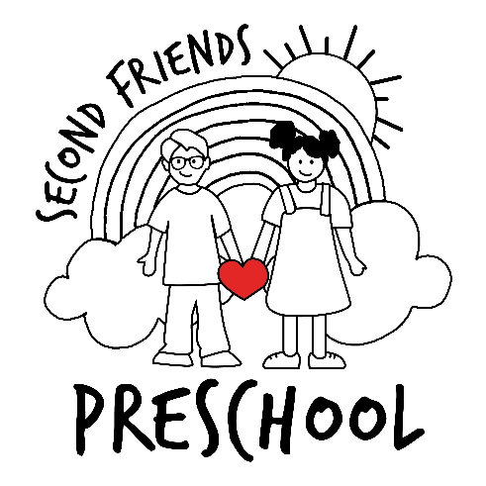

Second Baptist Church members faithfully support this preschool through financial contributions, prayer, and loving care.

Peanut and Tree Nut Free Snack Suggestion List
When choosing a peanut-free snack for your child’s class, it is important to always check the package label to ensure it is free of peanuts and all tree nuts. This list is intended to serve only as a resource. It is not comprehensive and may be affected by manufacturer recalls or mislabeling. Manufacturers may also change their equipment, product lines, or processes after this list was created.
In some classes, there may be children with food allergies beyond peanuts or tree nuts. Teachers will communicate any additional restrictions as needed. Some children with food sensitivities may bring their own snacks to ensure their safety at all times.
Do not send snack items to share if there is an allergy and ingredient alert such as:
“May Contain Peanut or Tree Nuts”
“Processed on shared equipment with Peanuts or Tree Nuts”
“Manufactured in a plant with Peanut or Tree Nuts”
“Contains Peanut or Tree Nut Ingredients”

Thank you for reading the labels and discussing the topic of “safe snacks” with your child.

FRUIT OR VEGGIES
Fresh Fruit (no strawberries due to potential allergies)
Fresh Veggies
Raisins (plain, not yogurt or chocolate covered)
Applesauce cups
Mandarin orange cups
Pear or Peaches cups
Fruit Snacks (Betty Crocker, Target, Annies Organic) NOT KELLOGG

DAIRY SNACKS
Danimals, Go-gurts, Trix yogurt
String Cheese (Sargento)
Kraft Cubes or sliced cheese

CEREAL/BARS
KELLOGG:
Nutra-Grain Bars (apple, cherry, raspberry, blueberry)
Pop Tarts
Apple Jacks
Rice Crispy Treats (prepackaged)
Corn Flakes
Corn Pops
Alpha Bits
Frosted Flakes
GENERAL MILLS:
Cinnamon Toast Crunch
Cheerios (regular, Fruity, Apple Cinnamon, frosted only)
Kix (plain)
Lucky Charms
Trix
Cocoa Puffs
Cookie Crisp

QUAKER OATS:
Life Cereal

CRACKERS
AUSTIN:
Zoo Animal Crackers

NABISCO:
Cheese Nips
Teddy Grahams (Cinnamon, Chocolate Chip, Honey, Chocolate)
Nilla Wafers
Barnum Animal Cracker
Honey Maid Graham Cracker –Chocolate, Cinnamon, Honey
Triscuits (plain)
Wheat Thins
Premium Saltines (original)
Better Cheddars
Ritz Crackers (not Ritz Bits)
Ritz Chips (original, cheddar)

KEEBLER:
Vanilla Wafers (golden, mini)
Elf Grahams (honey, cinnamon)
Scooby Doo Graham Crackers
Wheatables (original, honey wheat)
Club Crackers
5 pack cheese and pretzel dip
Town House Classic Crackers
Toasted (Wheat, Butter crisp)
Wheat Thins

SUNSHINE:
Cheeze-its
Big Cheeze-It

PEPPERIDGE FARM:
Goldfish Crackers (original, colors, cheddar, pretzel, giant, flavor blasted)

KRAFT:
Handi Snacks (breadsticks and cheese, Mister Salty and cheese, Oreo cookie sticks and cream, Ritz cracker and cheese)

ANNIES ORGANIC:
Organic Bunny Cheddar Crackers
Organic Traditional Snack Mix Bunnies
Organic Whole Wheat Bunny Crackers
Organic Sour Cream and Onion Bunnies
Organic Bunny Grahams

POPCORN (Recommended ages 4-5)
Pop Secret
Act 11
Jolly Time
Orville Redenbacher

PUDDING/JELLOS
Jell-O Gelatin and Pudding Cups
Hunts Pudding
Kraft Handi-Snacks Pudding Cups

DIPS
Kraft Ranch
T ‘Marzetti’s Buttermilk Ranch
T ‘Marzetti’s Veggie Ranch Dip
Hidden Valley Ranch
T ‘Marzetti’s Carmel Fruit Dip

CHIPS
ROLD GOLD:
Pretzels (rods, braided twists, tiny twist, cheddar)

FRITO LAY:
Doritos (any flavor)
Cheetos
LAYS Ruffles
Tostitos
Sun Chips (Original, Sour Cream, Cheddar, Flavored)
Fritos
LAYS BBQ, Plain

COOKIES
Nabisco Oreo (blue pack only)
Nabisco Oreo Golden (yellow package)
Rice Crispy Treats (prepackaged)
Enjoy Life (all flavors) **known for their allergen free cookies!
Lorna Doone shortbread cookies
Keebler Vanilla or Rainbow wafers
COLD TREAT
Popsicles, ice cups, swirled popsicles
Icee-Squeeze up tubes
Flavor Ice tubes
Minute Maid Frozen Lemonade

CANDY/SWEETS
Skittles (by Mars, Inc.)
Starburst (by Mars, Inc.)
Tootsie Rolls or Tootsie Pops
Smarties (by CE DE Candy)
Mike and Ike (by Just Born)
Twizzlers (by Hershey)
Laffy Taffy (by Nestle)
Life Saver Gummies (by Kraft)
Dum Dum sucker
Air Heads
Hershey Kisses (milk chocolate only)
DOVE Silky Smooth Promises (milk chocolate kind only)
Junior Mints
Yummy Earth Organic Lollipops
Kraft Marshmallow
Pillsbury Frosting (vanilla) blue container
**FYI: The FDA only regulates and labels allergens on food items. Other substances, such as potting soil, are not regulated. MIRACLE GROW potting soil contains nuts and should be avoided when participating in garden projects in the classroom.

